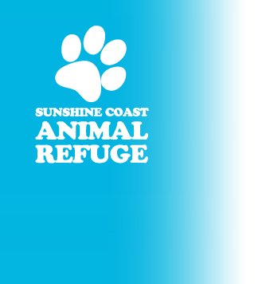
28 Sippy Creek Rd
Tanawha QLD 4556
www.sippycreek.com.au
07 5494 5275
BUSINESS SPONSORSHIP

Your Business sponsorship of the refuge is one way of helping to contribute towards the care of the hundreds of cats and dogs who come here for refuge before being re-homed. You can renew your sponsorship each year for another 1, 2 or 3 years. Sponsorship is renewed in either December or June each year. Please email manager@sippycreek.com.au for more information.

NAME
ADDRESS
Ph. | Email

I / We wish to commence / renew our Business sponsorship.

$1000 (Bronze Paws)

$2000 (Silver Paws)

$3000 (Gold Paws)

Please supply your business logo in pdf (vector) or high resolution jpeg. format so it can be added to our Business Sponsor Wall. Your logo will be displayed in A3 if you are a Gold Paws sponsor and A4 size for Bronze and Silver sponsors, either landscape or portrait.

Please also supply the relevant information so a business listing can be added to our website, and your Logo in a format that we can also load to our website.

For Gold & Silver Paws sponsors please also supply hard copies of your promotional material that you would like included in our adoption packs for the public.

Gold Paws sponsors please supply information so that a banner can be added to our website and enewletters with a link to your website.

Please Sign: _________________________________________ Date: _____________

Office Use Only Payment: EFTPOS CASH Cheque Bank Transfer
To Westpac 034229/Ac100574
Date Paid: One off payment Monthly deduction Sunshine Coast Animal Refuge

